

***Operating Lease Support System Phase-2 Project***

***for***

****

***Functional Specification***

***FC.AE.1.2***

***Monitor Billing Schedule***

Revision 0.3

**PT. Berlian Sistem Informasi**

KTB Annex Bld. 4th Floor, Jl. Jend. A. Yani. Pulomas,

Tel. +62 21 4786 7575 (Hunting) Fax. +62 21 4714964 www.bsi.co.id

Document Control

|  |  |
| --- | --- |
| **Author** | Amal Hamzah |
| **File Name** |  |
| **Directory Address** |  |
| **Number of Page** |  |

Revision History

|  |  |  |  |
| --- | --- | --- | --- |
| **Date** | **Revision** | **Description** | **Author** |
| 16/11/2015 | 0.0 | Initialization | Amal Hamzah |
| 16/12/2015 | 0.1 | Changes:   * Revise Directory Address (page 2) * Table of Contents (page 5) * Changing data type and size according FS common (page 30 – 32) * Adding table TB\_BIL\_MaintenanceDetail on Data Structure (page 33) * Adding table TB\_BIL\_InvoiceReceipt on Data Structure (page 34) * Complete Screen Item List of RPT.AE.1.1 Billing History Report (page 35) * Adding RPT.AE.1.2 Reminder Memo History Report on Screen Item List (page 36) | Amal Hamzah |
| 29/12/2015 | 0.2 | Changes:   * Screen of configuration access (page 8) * Adding field: Promise to Pay Date, Previous, Current and deleting Created By and Created Date (page 19, 21, 23, 27) | Amal Hamzah |
| 11/01/2015 | 0.3 | Changes:   * Changing Mr. Jin Nishimura to Mr. Yutaro Sanada as DSF Project Director on Distribution List (page 2) and Document Approval (page 3) * Adding pop up confirmation for pop up screen Promise to Pay Date (page 25) * Adding Description in Print Billing (Schedule/Overdue) History (page 29) * Adding pop up confirmation for pop up screen Reminder Memo (page 30) * Adding Application Server Machine for the time of report when button Print Report clicked (page 31) | Amal Hamzah |

Distribution List

|  |  |  |
| --- | --- | --- |
| Name | Organization | Roles |
| Mr. Yutaro Sanada | Dipo Star Finance, PT | DSF Project Director |
| Mr. Shinji Hosokawa | Dipo Star Finance, PT | DSF Project Advisor |
| Mr. Ahmad Fikri | Dipo Star Finance, PT | DSF Project Advisor |
| Mr. Abdul Somad | Dipo Star Finance, PT | DSF Project Manager |
| Mr. Delta Riangga | Dipo Star Finance, PT | DSF Key User |
| Mr. Mochamad Idris | Dipo Star Finance, PT | DSF Key User |
| Mrs. Herni Hembang | Dipo Star Finance, PT | DSF Key User |
| Mr. Junaidi Didy | Dipo Star Finance, PT | DSF Key User |
| Mr. Dedi Supriyadi | Dipo Star Finance, PT | DSF Key User |
| Mrs. Elke Hilviana | Dipo Star Finance, PT | DSF Key User |
| Mr. Mukhlis Ibrahim | Dipo Star Finance, PT | DSF IT Department Representative |
| Mr. Roby Wijaya | Dipo Star Finance, PT | DSF IT Department Representative |
| Mr. Daiki Kamada | Berlian Sistem Informasi, PT | BSI Project Director |
| Mr. Feri Irawan | Berlian Sistem Informasi, PT | BSI Project Advisor |
| Mr. Grand Zah Putra | Berlian Sistem Informasi, PT | BSI Project Manager |
| Mr. Amal Hamzah | Berlian Sistem Informasi, PT | BSI Business Analyst |

Document Approval

By signing this document I acknowledge I have read the document and give the Project Management Team approval to proceed.

|  |  |  |  |
| --- | --- | --- | --- |
| Role | Name | Signature | Date |
| DSF Project Director | Mr. Yutaro Sanada |  |  |
| DSF Project Advisor | Mr. Ahmad Fikri |  |  |
| DSF Project Manager | Mr. Abdul Somad |  |  |
| DSF IT Department Representative | Mr. Mukhlis Ibrahim |  |  |
| BSI Project Director | Mr. Daiki Kamada |  |  |
| BSI Project Advisor | Mr. Feri Irawan |  |  |
| BSI Project Manager | Mr. Grand Zah Putra |  |  |
| BSI Business Analyst | Mr. Amal Hamzah |  |  |

Table of Contents

Document Control 2

Revision History 2

Distribution List 4

Document Approval 5

1 Introduction 7

1.1 Purpose 7

1.2 Scope 7

1.3 Definition, Acronyms, and Abbreviations 7

1.4 References 8

2 Configuration 8

3 Specification Detail: FC.AE.1.2 Monitor Billing Schedule 8

3.1 Purpose 8

3.2 Screen of Configuration Access 9

3.3 Screen Functionality 9

3.4 Operation Flow 10

3.5 Screen Design 12

3.6 Component Screen Functionality 18

3.7 Operation Description 23

3.8 Data Structure 32

3.9 Screen Item List 36

3.10 Entity Relationship Diagram 40

* 1. Introduction
  2. Purpose

Functional Specification is a document to describe the detail of functions system which includes screen design and logic formula. This document will be used for system development.

* 1. Scope

Functional Specification Document contains screen design, screen functionality, process flow, and data structure of AE.1.2 Monitor Billing Schedule.

Here are the scopes for AE.1.2 Monitor Billing Schedule:

1. **AE.1.2.2 Monitor Billing**

To monitor billing payment schedule before due date and monitor billing overdue.

1. **AE.1.2.3 Create Reminder Memo**

To monitor billing payment schedule before due date and monitor billing overdue, including automatically send reminder by email.

1. **AE.1.2.4 Send and Receive Reminder by Email**

To send reminder of billing to customer by email when monitor agreement with 5 days and 1 day before due date.

Output from this functions is:

1. RPT.AE.1.1 Billing History report
2. RPT.AE.1.2 Reminder Memo History report
   1. Definition, Acronyms, and Abbreviations
3. OPL = Operating Lease
4. Due Date = End Usage Unit Date + TOP
5. TOP = Term Of Payment
6. RAL = Return Authorization Letter (Surat Kuasa Penarikan Unit)
7. BAST = Berita Acara Serah Terima (Handover Report)
8. DSF = Dipo Star Finance
9. HO = Head Office
10. HOB = Head of Branch
11. HOD = Head of Department
12. PIC = Person in Charge
13. Receipt = Kwitansi
14. Notification Letter (Surat Pemberitahuan)
15. Warning Letter (Surat Peringatan)
    1. References

This functional specification document refers to **“To Be Design” BSI Billing Collection Process**, module:

1. AE.1.1 Monitor Billing Schedule
   1. Configuration

Here will be described the format of Invoice, Receipt and RAL (Receipt Authorization Letter) document which will be generated when PIC Collection click Save as Draft button. The formats of these document numbers are:

No. Invoice Installment : 99999/INV/CABANG/MONTH/YEAR

No. Receipt : 99999/KW/CABANG/MONTH/YEAR

No. Invoice Maintenance : 99999/CSD-INV/CABANG/MONTH/YEAR

No. Maintenance Receipt : 99999/CSD-KW/CABANG/MONTH/YEAR

No. Receive Letter (Surat Tanda Terima) : 99999/OPL/TTD/CABANG/MONTH/YEAR

Description:

* The first 5 digits show the sequence number of the Invoice, Receipt and RAL documents. These numbers will increments whenever new Invoice, Receipt and RAL documents is created.
* The code on 3 digits for:
  1. INV represents Installment Invoice document
  2. KW represents Receipt document
  3. CSD-INV represents Maintenance Invoice document
  4. CSD-KW represents Maintenance Receipt document
  5. OPL/TTD represents Receive Letter (Surat Tanda Terima)
* The code ‘CABANG’ will be substituted by OPL Branch’s code
* The code ‘MONTH’ will be substituted by 2 digits of month when the document created.
* The code ‘YEAR’ will be substituted by 4 digits of year when the document is created.
  1. Specification Detail: FC.AE.1.2 Monitor Billing Schedule
  2. Purpose

Screen of Monitor Billing schedule will be used by PIC Collection to monitor payment billing on monthly base. This screen functions consist display list agreement with 7 days before end usage unit, 5 days before due date, 1 day before due date, agreement on due date and agreement on end contract. On this document also will describe screen functions for billing overdue which consist of display list of agreement billing overdue 1-30 days, 31-60 days, 61-90 days and >90 days. Monitoring will be based on end of period usage unit date (monthly basis) and due date (end of period usage unit date + Term of Payment).

This function covered by **“Monitor Billing Schedule”** screen

* 1. Screen of Configuration Access

Here are the accesses right for **“Monitor Billing Schedule”** screen users:

|  |  |  |  |  |  |
| --- | --- | --- | --- | --- | --- |
| ***User*** | ***Create*** | ***Read*** | ***Update*** | ***Print*** | ***Authorization*** |
| PIC Collection | v | v | v | V | v |
| Admin | v | v | v | V | v |
| Head of Branch | - | v | - | - | v |
| Head of Department | - | v | - | - | v |
| Regional Manager | - | v | - | - | v |
| Advisor | - | v | - | - | v |
| Director | - | v | - | - | v |
| President Director | - | v | - | - | v |
| Shareholder’s Meeting | - | v | - | - | v |

Legend: v = Have the access

Note:

1. Create: related to creation of billing schedule
2. Read: related to read display data billing schedule
3. Update: related to update data billing schedule
4. Print: related to print data billing schedule
5. Authorization: related to access to screen of data billing schedule
   1. Screen Functionality
6. Display monitor billing schedule for 7 days, 5 days, 1 day, due date and end contract
7. Display monitor billing overdue 1-30 days, 31-60 days, 61-90 days and >90 days
8. Send reminder billing to customer
9. Create history of reminder memo to customer
10. Print historical report billing schedule and billing overdue
    1. Operation Flow

Below is data flow for Monitor Billing Schedule process referring to **To Be Design Document Billing Collection**, AE.1.2. Monitor Billing Schedule:

|  |  |
| --- | --- |
| **PIC PC** | **Process** |
|  | monitor_billing7days.png  Agreement  (OPLAgreement)  Billing Payment Schedule Detail  (TB\_BIL\_PayScheduleDetail)  Billing Payment Schedule  (TB\_BIL\_PaySchedule)  Agreement Detail  (OPLAgreementDetail)  Note:  Source  Output & Input |

Below is data flow for Monitor Billing Overdue process referring to **To Be Design Document Billing Collection**, AE.1.2. Monitor Billing Schedule:

|  |  |
| --- | --- |
| **PIC PC** | **Process** |
|  | Agreement  (OPLAgreement)  Billing Payment Schedule Detail  (TB\_BIL\_PayScheduleDetail)  Billing Payment Schedule  (TB\_BIL\_PaySchedule)  Agreement Detail  (OPLAgreementDetail)  Note:  Source  Output & Input |

Below is data flow for Reminder Memo process referring to **To Be Design Document Billing Collection**, AE.1.2. Monitor Billing Schedule:

|  |  |
| --- | --- |
| **PIC PC** | **Process** |
|  | Billing Payment Schedule Detail  (TB\_BIL\_PayScheduleDetail)  Note:  Source  Output & Input    Reminder Memo  (TB\_BIL\_Reminder) |

* 1. Screen Design
* *Initial Screen Monitor Billing Schedule on tab 7 Days*

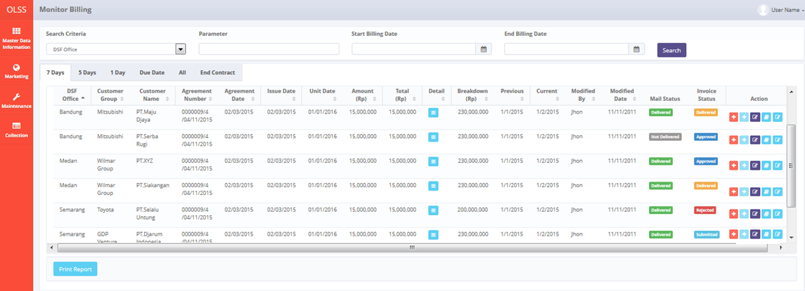

*Screen 1 Monitor Billing Schedule – 7 days tab*

* *Screen Design of Monitor Billing Schedule in tab 5 Days*

*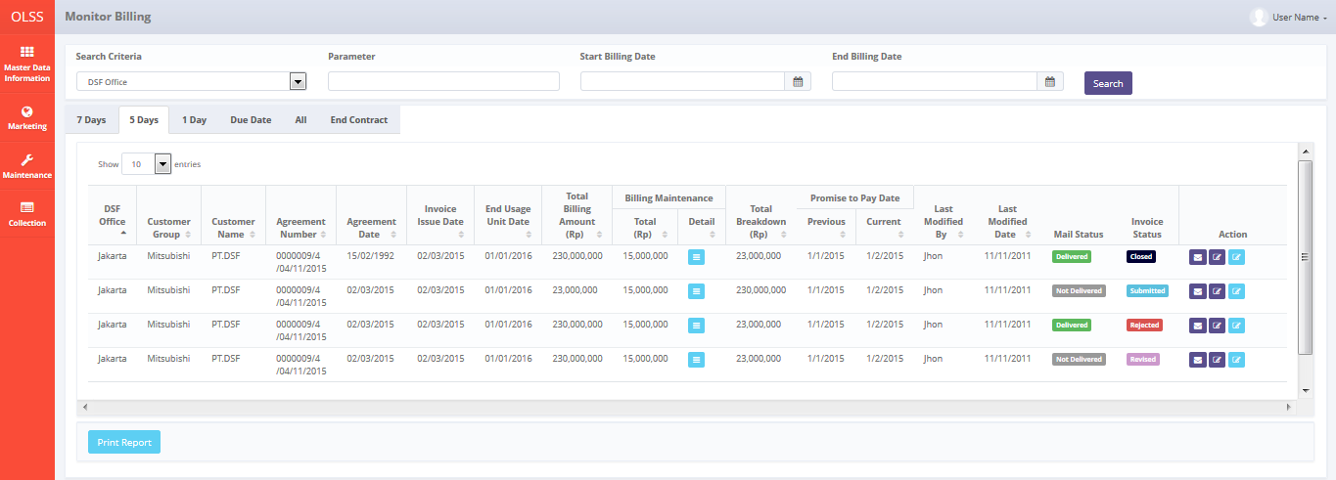*

*Screen 2 Monitor Billing Schedule – 5 days tab*

* *Screen Design of Monitor Billing Schedule in tab 1 Day*

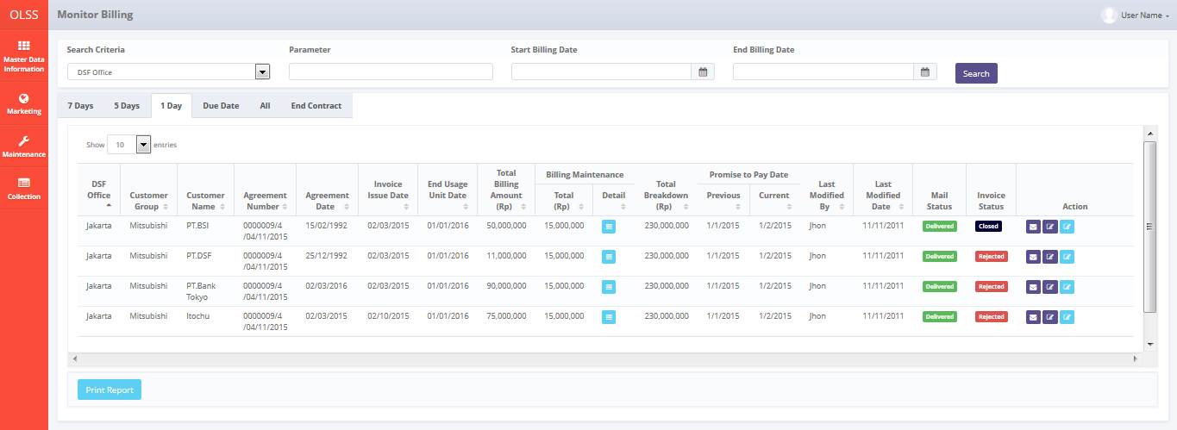

*Screen 3 Monitor Billing Schedule – 1 day tab*

* *Screen Design of Monitor Billing Schedule in tab Due Date*

*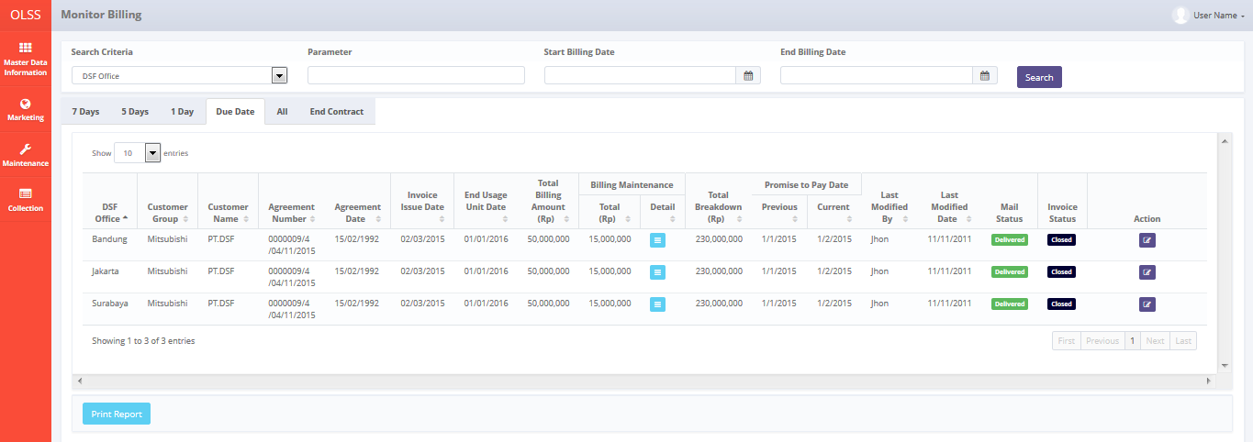*

*Screen 4 Monitor Billing Schedule – Due Date tab*

* *Screen Design of Monitor Billing Schedule in tab All*

*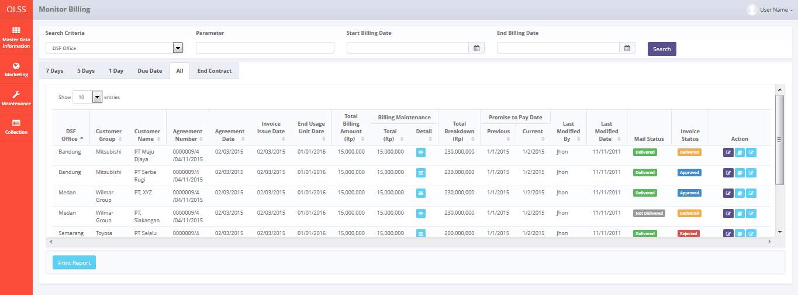*

*Screen 5 Monitor Billing Schedule – All tab*

* *Screen Design of Monitor Billing Schedule in tab End Contract*

*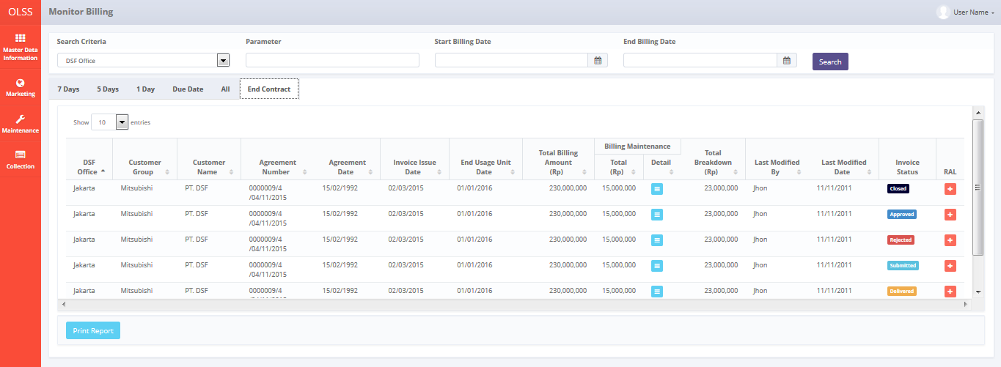*

*Screen 6 Monitor Billing Schedule – End Contract tab*

* *Screen Design of View Maintenance Billing Detail Pop Up Screen*

*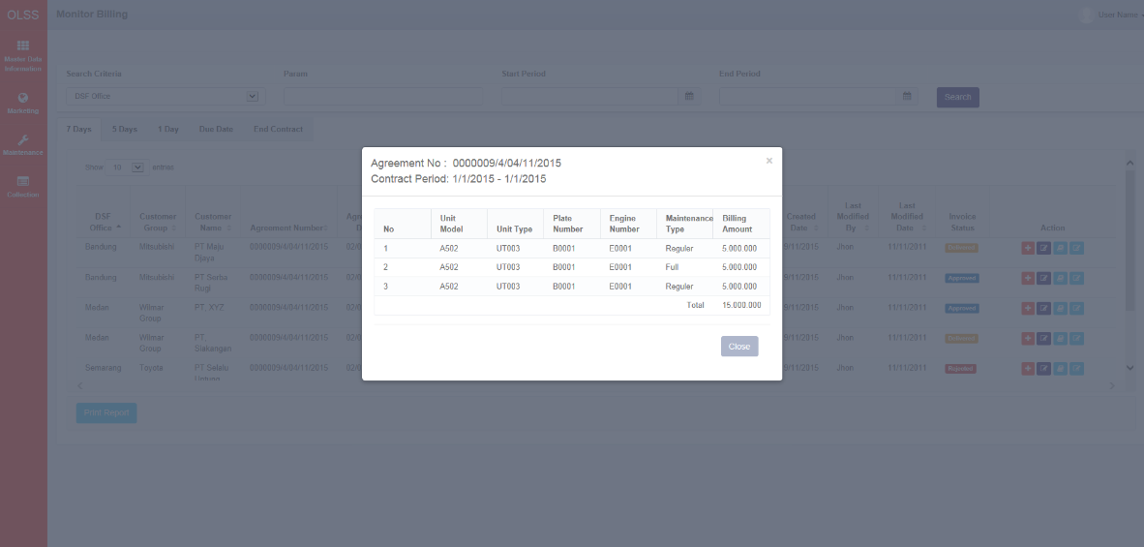*

*Screen 7 Monitor Billing Schedule – View Maintenance Billing Detail pop up screen*

* *Screen Design of Promise To Pay Pop Up Screen*

*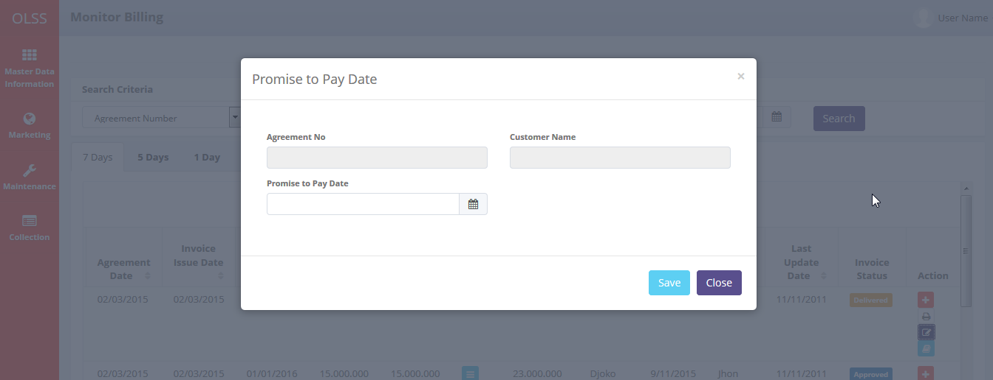*

*Screen 8 Monitor Billing Schedule – Promise to Pay pop up screen*

* *Screen Design of Monitor Billing Overdue on tab 1-30 Days*

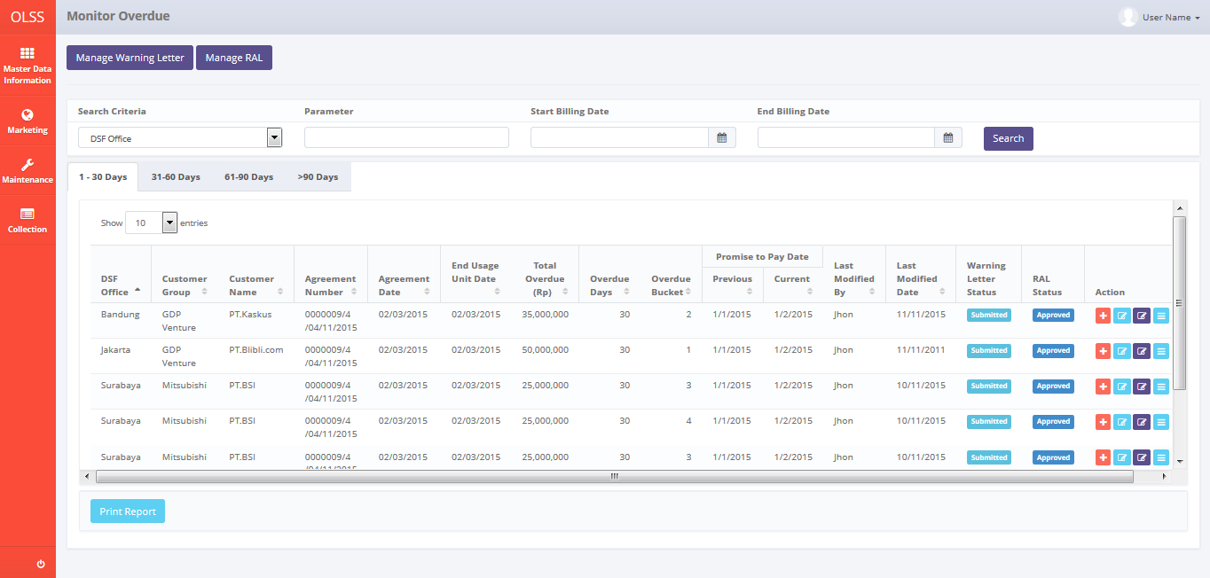

*Screen 9 Monitor Billing Overdue – 1-30 Days tab*

* *Screen Design of Monitor Billing Overdue on tab 31-60 Days*

*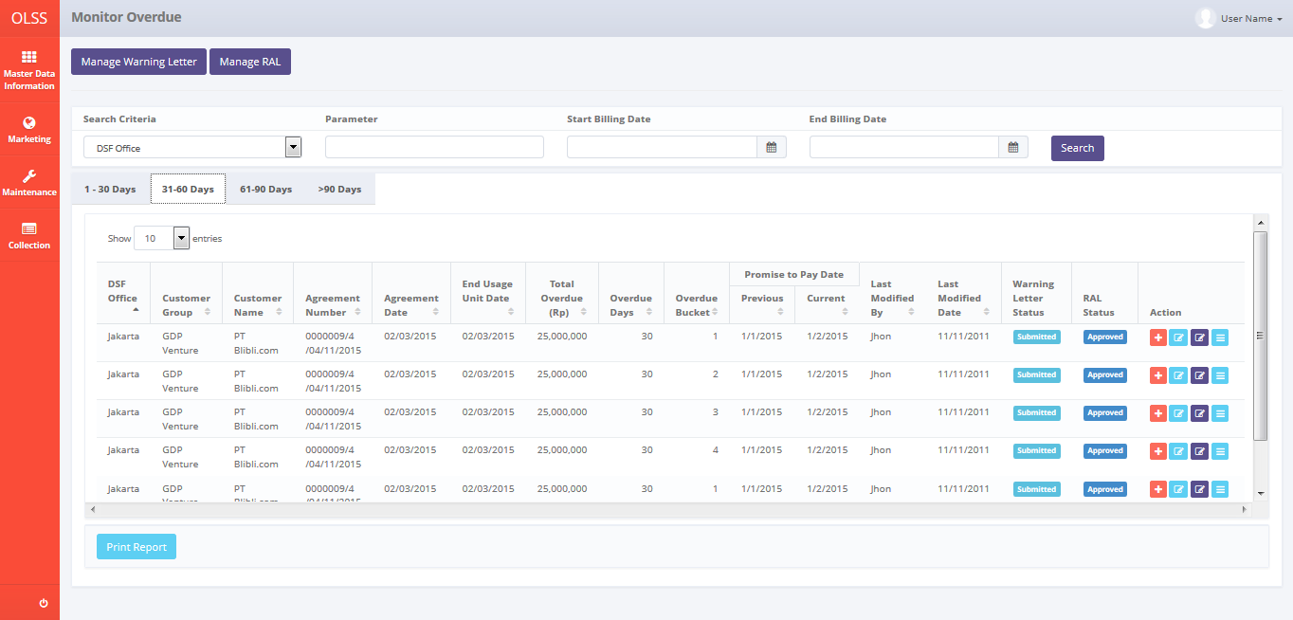*

*Screen 10 Monitor Billing Overdue – 31-60 Days tab*

* *Screen Design of Monitor Billing Overdue on tab 61-90 Days*

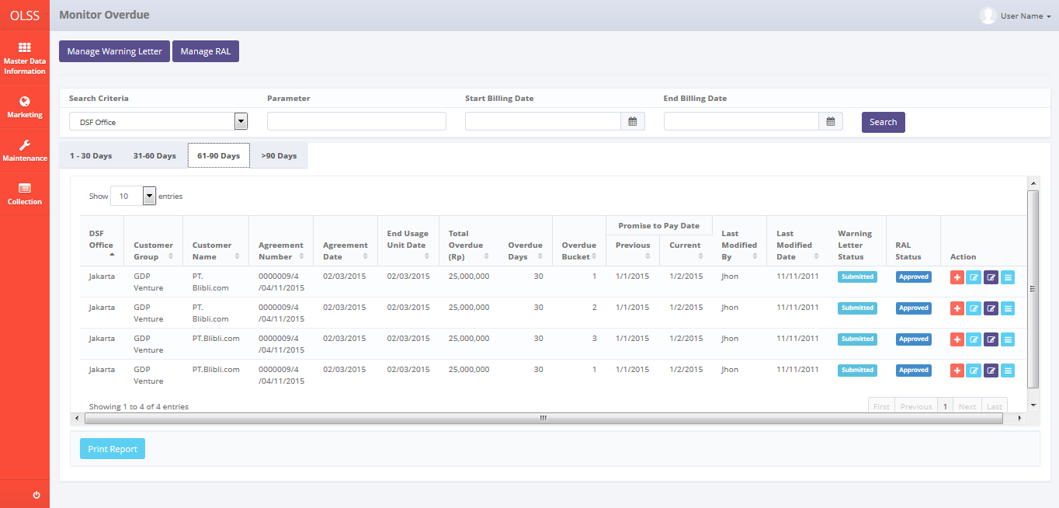

*Screen 11 Monitor Billing Overdue – 61-90 Days tab*

* *Screen Design of Monitor Billing Overdue on tab >90 Days*

*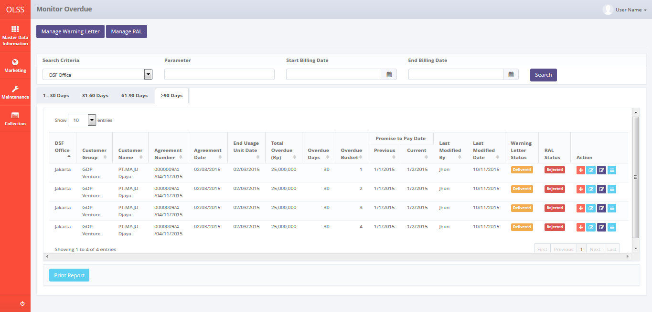*

*Screen 12 Monitor Billing Overdue – >90 Days tab*

* *Screen Design of Create Reminder Memo Pop Up Screen*

*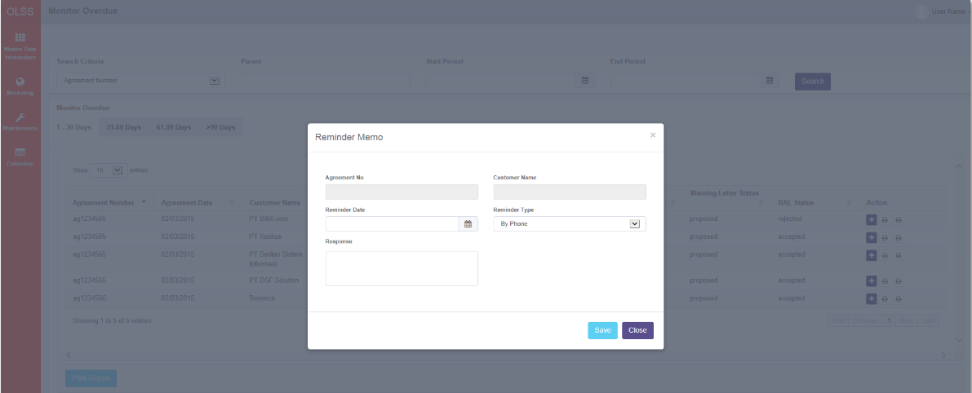*

*Screen 13 Monitor Billing Overdue – Create Reminder Memo Pop Up Screen*

* *Screen Design of Reminder Memo History Pop Up Screen*

*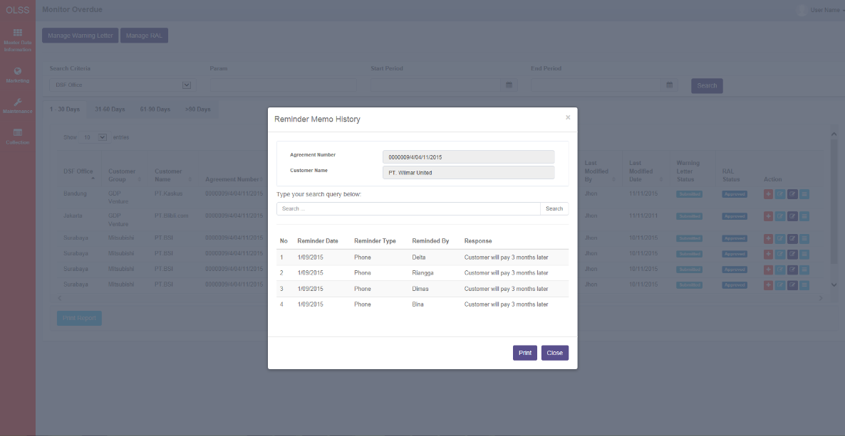*

*Screen 14 Monitor Billing Overdue – Reminder Memo History Pop Up Screen*

* *Notification after Click button Send Reminder Email*

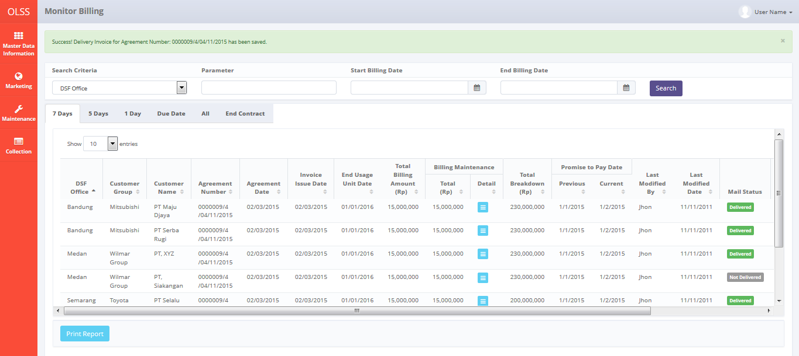

*Screen 15 Notification After click button Send Reminder Email*

* 1. Component Screen Functionality

1. **Monitor Billing**

Here are the screen functions from each component in **Screen 1, 2, 3, 4, 5, 6. Monitor Billing Schedule**:

|  |  |  |  |
| --- | --- | --- | --- |
| ***No*** | ***Component*** | ***Name*** | ***Function*** |
| **Header** | | | |
| 1 | Label | Monitor Billing | Monitor Billing Title |
| **Search Criteria** | | | |
| 2 | Drop down box | Search Criteria | To select category for searching agreement billing data |
| 3 | Text Field | Parameter | To input parameter for searching agreement billing data |
| 4 | Date Picker | Start Billing Date | To input start period based on update date when print agreement billing data report |
| 5 | Date Picker | End Billing Date | To input end period based on update date when print agreement billing data report |
| 6 | Button | Search | To search agreement billing data based on selected criteria |
| **List of Agreements** | | | |
| 7 | Drop down | Show Entries | To select number of row data that will be displayed in one screen (paging) |
| 8 | Button | Print | To print report unit preparation status as shown on the list |
| 9 | Tab | 7 Days | To display agreements with 7 calendar days before end usage unit date |
| 10 | Tab | 5 Days | To display agreements with 5 calendar days before due date |
| 11 | Tab | 1 Day | To display agreements with 1 calendar day before due date |
| 12 | Tab | Due Date | To display agreements on due date |
| 13 | Tab | End Contract | To display agreement on last billing month to end contract |
| 14 | Button | Sort | To sort data on table list of agreements ascending and descending |
| 15 | Label | DSF Office | To display Dipo Star Finance Office Branch |
| 16 | Label | Customer Group | To display Group of customer |
| 17 | Label | Customer Name | To display Customer name |
| 18 | Label | Agreement Number | To display Agreement number |
| 19 | Label | Agreement Date | To display Agreement date |
| 20 | Label | Invoice Issue Date | To display invoice issue date |
| 21 | Label | End Usage Unit Date | To display end usage unit date |
| 22 | Label | Total Billing Amount (Rp) | To display total billing amount |
| 23 | Label | Billing Maintenance | To display total billing maintenance and detail of billing maintenance |
| 24 | Label | Total (Rp) | To display total billing maintenance |
| 25 | Button | Detail | To display billing maintenance detail in period contract |
| 26 | Label | Total Breakdown (Rp) | To display total breakdown |
| 27 | Label | Promise to Pay Date | To display previous and current promise to pay date |
| 28 | Label | Previous | To display previous Promise to Pay date data stated by customer |
| 29 | Label | Current | To display latest Promise to Pay date data stated by customer |
| 30 | Label | Last Modified by | To display user name who make last modification on billing data |
| 31 | Label | Last Modified Date | To display the date when billing data last modified |
| 32 | Label | Mail Status | To display status of email delivery of invoice |
| 33 | Label | Invoice Status | To display status of invoice document |
| 34 | Label | Action | To display action buttons for every list of data |
| 35 | Button | Create Invoice | To create new invoice and receipt |
| 36 | Button | Set Delivery Date | To input the date of invoice delivery to customer by courier |
| 37 | Button | Input Promise to Pay | To input the date of promise to pay |
| 38 | Button | List of Invoice Status | To display list of invoice status |
| 39 | Button | Edit Billing Payment | To edit billing of payment |
| 40 | Button | Send reminder | To send reminder by email on 5 days and 1 day before due date |
| 41 | Button | Create RAL | To create RAL on end contract |
| 42 | Label | Showing N to M of X entries | Displaying agreement data sequence and the total of agreement data |
| 43 | Link | First Page | To display first entries page of agreement data |
| 44 | Link | Previous Page | To display the previous entries page of agreement data |
| 45 | Link | Page Number | Displaying the page number of the list |
| 46 | Link | Next Page | To display the next entries page of agreement data |
| 47 | Link | Last Page | To display the last entries page of agreement data |

1. **Monitor Billing Overdue**

Here are the screen functions from each component in **Screen 9, 10, 11, 12. Monitor Overdue:**

|  |  |  |  |
| --- | --- | --- | --- |
| ***No*** | ***Component*** | ***Name*** | ***Function*** |
| **Header** | | | |
| 1 | Label | Monitor Overdue | Monitor Overdue Title |
| **Search Criteria** | | | |
| 2 | Drop down box | Search Criteria | To select category for searching agreement billing data |
| 3 | Text Field | Parameter | To input parameter for searching agreement billing data |
| 4 | Date Picker | Start Billing Date | To input start period based on update date when print agreement billing data report |
| 5 | Date Picker | End Billing Date | To input end period based on update date when print agreement billing data report |
| 6 | Button | Search | To search agreement billing data based on selected criteria |
| **List of Agreements** | | | |
| 7 | Drop down | Show Entries | To select number of row data that will be displayed in one screen (paging) |
| 8 | Button | Print Report | To print report billing data as shown on the list |
| 9 | Tab | 1 – 30 Days | To display agreements with overdue from 1 to 30 calendar days |
| 10 | Tab | 31 – 60 Days | To display agreement with overdue from 31 to 60 calendar days |
| 11 | Tab | 61 – 90 Days | To display agreement with overdue from 61 to 90 calendar days |
| 12 | Tab | >90 Days | To display agreement with overdue more than 90 calendar days |
| 13 | Button | Sort | To sort data on table list of agreements ascending and descending |
| 14 | Label | DSF Office | To display Dipo Star Finance Office Branch |
| 15 | Label | Customer Group | To display Group of customer |
| 16 | Label | Customer Name | To display Customer name |
| 17 | Label | Agreement Number | To display Agreement number |
| 18 | Label | Agreement Date | To display Agreement date |
| 19 | Label | End Usage Unit Date | To display end usage unit date of period of contract |
| 20 | Label | Total Overdue (Rp) | To display remaining total overdue of billing agreement |
| 21 | Label | Overdue Days | To display accumulate overdue days of billng agreement |
| 22 | Label | Overdue Bucket | To display overdue bucket of billing agreement |
| 23 | Label | Promise to Pay Date | To display previous and current promise to pay date |
| 24 | Label | Previous | To display previous promise to pay date stated by customer |
| 25 | Label | Current | To display latest promise to pay date stated by customer |
| 26 | Label | Last Modified by | To display user name who make last modification on billing data |
| 27 | Label | Last Modified Date | To display the date when billing data last modified |
| 28 | Label | Warning Letter Status | To display latest status of Warning Letter |
| 29 | Label | RAL Status | To display latest status of RAL |
| 30 | Label | Action | To display action buttons for every list of data |
| 30 | Button | Create Reminder Memo | To input reminder memo conducted by PIC Collection to customer |
| 31 | Button | Create Warning Letter | To create and print Warning Letter for overdue billing agreement |
| 32 | Button | Create RAL | To create and print Return Authorization Letter (RAL) for billing agreement |
| 33 | Button | Detail | To display Reminder Memo Detail History Pop Up Screen |
| 34 | Label | Showing N to M of X entries | Displaying agreement data sequence and the total of agreement data |
| 35 | Link | First Page | To display first entries page of agreement data |
| 36 | Link | Previous Page | To display the previous entries page of agreement data |
| 37 | Link | Page Number | Displaying the page number of the list |
| 38 | Link | Next Page | To display the next entries page of agreement data |
| 39 | Link | Last Page | To display the last entries page of agreement data |

1. **View Maintenance Billing Detail Pop Up Screen**

Here are the screen functions from each component in **Screen 7. Monitor Billing Schedule – View Maintenance Billing Detail Pop Up Screen:**

|  |  |  |  |
| --- | --- | --- | --- |
| ***No*** | ***Component*** | ***Name*** | ***Function*** |
| **Header** | | | |
| 1 | Label | Agreement No | To view selected Agreement Number |
| 2 | Label | Contract Period | To view Contract Period of selected Agreement |
| **Data** | | | |
| 3 | Label | No | To view number of maintenance data |
| 4 | Label | Unit Model | To view Unit Model in maintenance |
| 5 | Label | Unit Type | To view Unit Type in maintenance |
| 6 | Label | Plate Number | To view plate number of unit in maintenance |
| 7 | Label | Engine Number | To view engine number of unit in maintenance |
| 8 | Label | Maintenance Type | To view maintenance type |
| 9 | Label | Billing Amount | To view billing amount of maintenance |
| 10 | Label | Total | To view total of billing amount of maintenance |
| 11 | Button | Close | To close pop up screen without create data |

1. **Promise to Pay Pop Up Screen**

Here are the screen functions from each component in **Screen 8. Monitor Billing Schedule – Promise to Pay Pop Up Screen:**

|  |  |  |  |
| --- | --- | --- | --- |
| ***No*** | ***Component*** | ***Name*** | ***Function*** |
| **Data** | | | |
| 1 | Text Field | Agreement No | To view selected Agreement Number |
| 2 | Text Field | Customer Name | To view Customer Name of selected Agreement |
| 3 | Datetime Picker | Promise to Pay Date | To input the date of promising to pay confirmed by Customer |
| 4 | Button | Save | To close pop up screen with saving changes data |
| 5 | Button | Close | To close pop up screen without saving changes data |

1. **Create Reminder Memo Pop Up Screen**

Here are the screen functions from each component in **Screen 13. Create Reminder Memo Pop Up Screen:**

|  |  |  |  |
| --- | --- | --- | --- |
| ***No*** | ***Component*** | ***Name*** | ***Function*** |
| **Header** | | | |
| 1 | Label | Reminder Memo | Reminder Memo Title |
| **Data** | | | |
| 2 | Text Field | Agreement Number | To view selected agreement Number |
| 3 | Text Field | Customer Name | To view selected Customer Name |
| 4 | Datetime Picker | Reminder Date | To input reminder date |
| 5 | Datetime Picker | Promise to Pay Date | To input promise to pay date confirmed by customer |
| 6 | Combobox | Reminder Type | To input reminder type |
| 7 | Text Area | Response | To input response of customer |
| 8 | Button | Save | To create reminder memo data and automatically close pop up screen |
| 9 | Button | Close | To close pop up screen without create data |

* 1. Operation Description

1. **Monitor Billing Schedule**

|  |  |  |
| --- | --- | --- |
| **No.** | **Operation Name** | **Description** |
| 1 | Initial view of Monitor Billing Schedule | The screen of monitor billing schedule:   * 1. Component Status;  |  |  |  |  | | --- | --- | --- | --- | | Component | Name/Caption | Status | Remark | | Label | Monitor Billing | Not Active |  | | Drop down box | Search criteria | Active | As initial by default column name that will be display on drop down is DSF Office | | Text Field | Search criteria value | Active | Value:   * DSF Office * Customer Group * Customer Name * Agreement Number * Agreement Date * Invoice Issue Date * End Usage Unit Date * Total Billing Amount * Total Billing Maintenance * Total Breakdown * Promise to Pay Date * Last Modified By * Last Modified Date * Mail Status * Invoice Status | | Label | DSF Office | Not Active |  | | Label | Customer Group | Not Active |  | | Label | Customer Name | Not Active |  | | Label | Agreement Number | Not Active |  | | Label | Agreement Date | Not Active |  | | Label | Invoice Issue Date | Not Active |  | | Label | End Usage Unit Date | Not Active |  | | Label | Total Billing Amount (Rp) | Not Active |  | | Label | Billing Maintenance | Not Active |  | | Label | Total | Not Active |  | | Label | Detail | Active | Active depending on existence of billing maintenance on billing period | | Label | Total Breakdown (Rp) | Not Active |  | | Label | Promise to Pay Date | Not Active |  | | Label | Previous | Not Active |  | | Label | Current | Not Active |  | | Label | Last Modified By | Not Active |  | | Label | Last Modified Date | Not Active |  | | Label | Mail Status | Not Active |  | | Label | Invoice Status | Not Active |  | | Label | Action | Not Active |  | | Link | First Page | Active | Active depending on the current entry | | Link | Previous Page | Active | Active depending on the current entry | | Link | Page Number | Active | Active depending on the current entry | | Link | Next Page | Active | Active depending on the current entry | | Link | Last Page | Active | Active depending on the current entry |     Constraint:   1. For billing data on 7 days tab, only display billing data with 6 and 7 calendar days before end usage unit date and billing data with special condition set yes to create invoice on that date. 2. For billing data on 5 days tab, only display billing data from 2 calendar days to 5 calendar days before due date (end usage unit date + TOP). 3. For billing data on 1 day tab, only display billing data with 1 calendar day before due date (end usage unit date + TOP) 4. For billing data on Due Date tab, only display billing data on due date. 5. For billing data on End Contract tab, only display billing data on the end of contract. |
| 2 | Searching the List of Billing of Agreement | Input:   1. Select searching criteria category (search criteria), searching criteria value (param), Start Period (End usage unit date) and End Period (End usage unit date) in search field       Constraint:   1. Search criteria only consists of Customer Group, Customer Name, Agreeement Number, Agreement Date, Invoice Issue Date, End Usage Unit Date, Total Billing Amount, Total Breakdown, and Invoice Status (the same as the lists) generated from Tb\_OPL\_SearchCriteria mapping 2. End Period can not be less than Start Period (the End Period will be locked for the date before Start Date) 3. Start Period can not be more than End Period (the Start Period will be locked for the date after End Date) 4. For monitor billing schedule on all tab will display list of all agreement data with status ACTIVE and already has billing schedule 5. For monitor billing schedule on 7 days tab will display list of agreement with 7 days before end of usage period date or list of agreement with special condition for print invoice. 6. For monitor billing schedule on 5 days tab will display list of agreement with 5 days before due date (end of usage period date + Term of payment) 7. For monitor billing schedule on 1 day tab will display list of agreement with 1 day before due date (end of usage period date + Term of payment) 8. For monitor billing schedule on due date tab will display list of agreement on due date 9. For monitor billing schedule on end contract tab will display list of agreement on end contract period (last period of contract) 10. Click on the Search Button      1. The screen will view the list of agreement according to criteria 2. Based on **Screen Monitor Billing Schedule – 7 Days, 5 Days, 1 Day, Due Date and End Contract**, information related to Billing Agreement that will be display automatically are:  * DSF Office * Customer Group * Customer Name * Agreement Number * Agreement Date * End Usage Unit Date * Invoice Issue Date * Total Billing Amount * Total Breakdown * Created By * Created Date * Last Modified By * Last Modified Date * Invoice status  1. Number data row on list will be based on selected show number entries 2. Select number of show list entries: 10, 25, 50, and 100 and click the page for viewing more data   Process:   1. Default view will display data list of agreements with status “OPEN” and 7 days before end usage unit date or agreements with status “OPEN” with special case where already set date for print invoice 2. List of agreements will be sorted descending by agreement created date 3. After click the Search button, the system will get data from Tb\_BIL\_PayScheduleDetail table to be displayed in the list   Output:   1. Display list data of agreement |
| 3 | Maintenance Detail | Input:   1. Click the button Maintenance Detail on the list of billing schedule screen 2. Maintenance Detail pop up screen will display with the following field:  * Agreement No * Contract Period * Unit Model * Unit Type * Plate Number * Engine Number * Maintenance Type * Billing Amount   Constraint:   1. Only maintenance on billing period will be taken to billing invoice 2. If PIC Maintenance input billing maintenance after generate invoice, then it will be taken on next period of invoice 3. Only agreement with maintenance type = CSD and back cash to customer will be taken to invoice billing 4. If maintenance billing already take to billing invoice, status will change to “already billed”   Process:   1. Click “Close” button to close pop up screen.     Output:  N/A |
| 4 | Promise to Pay | Input:   1. Click the button input promise to pay on the list of billing schedule screen 2. Input/select the following field:  * Agreement No (disabled, already inputted by system) * Customer Name (disabled, already inputted by system) * Promise to Pay Date   Process:   1. Click “Save” button to save the inputted data and close pop up screen. 2. When click button Save, will trigger a pop up screen for validation **“Are sure you want to input Promise to Pay Date for Agreement Number: xxxx?”** 3. Click “Close” button to close pop up screen without saving data. 4. When click button Close, if user already input data, will trigger a popup screen for validation **“Are your you want to quit without saving data?”**   Output:  N/A |
| 5 | Send Reminder email | Input:   1. Click the button Send Reminder Email of billing schedule screen   Constraint:   1. Customer PIC must have email address 2. If customer PIC doesn’t have email address, then the button Send Reminder Email will be disabled   Process:   1. Send invoice by email to customer 2. Save data to table Tb\_BIL\_ReminderMemoHistory 3. Data to save:  |  |  |  | | --- | --- | --- | | Name/Caption | Status | Remark | | Invoice ID | Active |  | | Reminder Status | Active |  | | Reminder Type | Active |  | | Reminder Date | Active |  | | Reminder Remarks | Active |  | | Created Date | Active |  | | Created By | Active |  | | Last Modified Date | Active |  | | Last Modified By | Active |  |   Output:   1. Email of invoice |
| 6 | Initial view of Monitor Overdue | The screen of monitor billing overdue:   * 1. Component Status;  |  |  |  |  | | --- | --- | --- | --- | | Component | Name/Caption | Status | Remark | | Label | Monitor Overdue | Not Active |  | | Drop down box | Search criteria category | Active | As initial by default column name that will be display on drop down is DSF Office | | Text Field | Search criteria value | Active | Value:   * DSF Office * Customer Group * Customer Name * Agreement Number * Agreement Date * End Usage Unit Date * Total Overdue * Overdue Days * Overdue Bucket * Promise to Pay Date * Last Modified By * Last Modified Date * Warning Letter Status * RAL Status | | Label | DSF Office | Not Active |  | | Label | Customer Group | Not Active |  | | Label | Customer Name | Not Active |  | | Label | Agreement Number | Not Active |  | | Label | Agreement Date | Not Active |  | | Label | End Usage Unit Date | Not Active |  | | Label | Total Overdue | Not Active |  | | Label | Overdue Days | Not Active |  | | Label | Overdue Bucket | Not Active |  | | Label | Promise to Pay Date | Not Active |  | | Label | Previous | Not Active |  | | Label | Current | Not Active |  | | Label | Last Modified By | Not Active |  | | Label | Last Modified Date | Not Active |  | | Label | Warning Letter Status | Not Active |  | | Label | RAL Status | Not Active |  | | Label | Action | Not Active |  | | Link | First Page | Active | Active depending on the current entry | | Link | Previous Page | Active | Active depending on the current entry | | Link | Page Number | Active | Active depending on the current entry | | Link | Next Page | Active | Active depending on the current entry | | Link | Last Page | Active | Active depending on the current entry |     Constraint:   * 1. For billing overdue data on 1-30 days tab, only display billing data with overdue from 1 to 30 calendar days.   2. For billing overdue data on 31-60 days tab, only display billing data with overdue from 31 to 60 calendar days.   3. For billing overdue data on 61-90 days tab, only display billing data with overdue from 61 to 90 calendar days.   4. For billing overdue data on >90 days tab, only display billing data with overdue more than 90 calendar days.   5. Overdue means current date more than Due Date (End usage unit date + TOP) and customer not conduct payment yet. |
| 7 | Searching the List of Overdue Billing of Agreement | Input:   1. Select searching criteria category (search criteria), searching criteria value (parameter), Start Period (End usage unit date) and End Period (End usage unit date) in search field       Constraint:   1. Search criteria only consists of Customer Group, Customer Name, Agreeement Number, Agreement Date, Invoice Issue Date, End Usage Unit Date, Total Billing Amount, Total Breakdown, and Invoice Status (the same as the lists) generated from Tb\_OPL\_SearchCriteria mapping 2. End Period can not be less than Start Period (the End Period will be locked for the date before Start Date) 3. Start Period can not be more than End Period (the Start Period will be locked for the date after End Date) 4. If parameter type is date, then only Start Period and End Period are active, 5. For monitor billing schedule on all tab will display list of all agreement data with status ACTIVE and already has billing schedule 6. For monitor overdue on 1-30 Days tab will display list of agreements with overdue payment instalment between 1 to 30 days. 7. For monitor overdue on 31-60 Days tab will display list of agreements with overdue payment instalment between 31 to 60 days. 8. For monitor overdue on 61-90 Days tab will display list of agreements with overdue payment instalment between 61 to 90 days. 9. For monitor overdue on <90 Days tab will display list of agreements with overdue payment instalment more than 90 days. 10. Click on the Search Button      1. The screen will view the list of agreement according to criteria 2. Based on **Screen Monitor Billing Overdue – 1-30 Days, 31-60 Days, 61-90 Days and >90 Days**, information related to Billing Agreement that will be display automatically are:  * DSF Office * Customer Group * Customer Name * Agreement Number * Agreement Date * Total Overdue * Overdue Days * Overdue Bucket * Promise to Pay Date * Previous * Current * Last Modified By * Last Modified Date * Warning Letter status * RAL Status  1. Number data row on list will be based on selected show number entries 2. Select number of show list entries: 10, 25, 50, and 100 and click the page for viewing more data   Process:   1. Default view will display data list of agreements with status “OPEN” and 7 days before end usage unit date or agreements with status “OPEN” with special case where already set date for print invoice 2. List of agreements will be sorted descending by created date 3. After click the Search button, the system will get data from Tb\_BIL\_PayScheduleDetail table to be displayed in the list   Output:   1. Display list data of overdue billing |
| 8 | Input Reminder Memo | Input:   1. Click the button of Create Reminder Memo on the list of billing overdue screen      1. By click button Reminder Memo will trigger Reminder Memo Pop Up Screen 2. Insert the following field:  * Reminder Date (required) * Reminder Type (required) * Response (required) * Promise to Pay (if any)   Constraint:   1. Date picker component will initially select today of system date for reminder date and promise to pay 2. Only date before or equal with today can be inputted in Reminder Date 3. Only date after today date can be inputted in Promise to Pay 4. Dropdown component will display “By Phone” and “By Visit” value and will initially select “By Phone” for Reminder Type 5. Every field inputted cannot exceed maximum length defined in database system 6. From step 2, click on Save button to save reminder memo 7. When click on button Save, will trigger a pop up screen for validation **“Are sure you want to input Reminder Memo for Agreement Number: xxxx?”** 8. Or from step 2, click on Close button to close reminder memo pop up screen without saving data 9. When click button Close, if user already input data, will trigger a popup screen for validation **“Are your you want to quit without saving data?”**   Constraint:   1. If clicked with any of the field still hasn’t meet the validation criteria, every notification message for validation below the field will be generated (notification “This field is required” for mandatory field)   Process:   1. Inputting Reminder Memo in table Tb\_BIL\_ReminderMemoHistory |
| 9 | Print Billing (Schedule/Overdue) History | Input:   1. Access menu OLSS 2. Hover to menu Collection 3. Click on Monitor Schedule sub menu 4. Select Search Criteria Drop down box and click among these:  |  |  | | --- | --- | | **Search Criteria** | **Constraint Input** | | DSF Office | Varchar | | Customer Group | Varchar | | Customer Name | Varchar | | Agreement Number | Varchar | | Agreement Date | Datetime | | End Usage Unit Date | Datetime | | Total Overdue | Decimal | | Overdue Days | Integer | | Overdue Bucket | Integer | | Last Modified By | Varchar | | Last Modified Date | Datetime |   Constraint:   1. Validation of parameter based on the contraint value will be executed when user click search button. 2. For Agreement Date, End Usage Unit Date and Last Modified Date will save to database as complete Datetime data, but when display on screen the format will be MM/dd/yyyy 3. Select Start and End date period to filter based on the Billing date     Constraint:   * 1. End Agreement Date can not be less than Start Agreement Date (the End Agreement Date will be locked for the date before Start Date).   2. Start Agreement Date can not be less than End Agreement Date (the Start PO Creation Date will be locked for the date after End Date).   3. Validation will be executed when user click search button.  1. Click Search button:   D:\Users\bsi00815\AppData\Local\Microsoft\Windows\Temporary Internet Files\Content.Word\Visit Customer Survey Report.png   1. List of data which will be printed will be shown at the list. To print those data as Billing report, user should click Print Report button:     Process:   1. User can view list of Billing data which will be printed, in the Billing search result list. 2. Informations related to Billing that will be printed are:    1. DSF Office    2. Customer Group    3. Customer Name    4. Agreement Number    5. Agreement Date    6. End Usage Unit Date    7. Total Overdue    8. Overdue Days    9. Overdue Bucket    10. Previous (Promise to Pay Date)    11. Current (Promise to Pay Date)    12. Last Modified By    13. Last Modified Date 3. List of agreements will be sorted descending by created date   Output:   1. Billing Schedule Report will be saved as Billing Schedule Report\_MMddyyyy\_hhmm, where MMddyyyy and hhmm is the time of Application Server Machine when button Print Report is clicked.   Alternative:  N/A |
| 10 | Print Reminder Memo History | Input:   1. Access menu OLSS 2. Hover to menu Billing Collection 3. Click on Monitor Schedule sub menu 4. Click button Reminder Memo Detail      1. List of data which will be printed will be shown at this list. To print those data as Reminder Memo Report, user should click Print button:     Process:   1. User can view list of reminder memo data which will be printed, in the memo search result list. 2. Informations related to reminder memo that will be printed are:    1. Agreement Number    2. Customer Name    3. Reminder Date    4. Reminder Type    5. Reminder By    6. Response 3. Reminder memo data will be sorted based on the oldest reminder date at list of reminder memo data. The oldest reminder date will be listed on top. Sorted descending by Created Date.   Output:   1. Reminder Memo Report will be saved as Reminder Memo Report\_MMddyyyy\_hhmm, where MMddyyyy and hhmm is the time of Application Server Machine when button Print is clicked.   Alternative:  N/A |
| 11 | System Error Message | Process:   1. Any kind of errors out of application validation or cannot be handled by application such as error when communicate with database server, bugs, overloop etc will generate error message:   “System error. Please contact your administrator”  Output:   1. A page with system error message will appear. |

* 1. Data Structure

1. **TB\_BIL\_PaySchedule**

|  |  |  |  |  |  |  |
| --- | --- | --- | --- | --- | --- | --- |
| *Field Name* | *Data Type* | *Length* | *Source* | *Remarks* | *Nullable* | *Mandatory* |
| IdTB\_BIL\_PaySchedule | *Integer* | *N/A* | TB\_BIL\_PaySchedule.IdTB\_BIL\_PaySchedule | ***Primary Key*** | *No* | *Yes* |
| IdOPLAgreement | *Integer* | *N/A* | OPLAgreement.IdOPLAgreement | ***Foreign Key*** | *No* | *Yes* |
| CollectionAmt | *Decimal* | *18,3* | TB\_BIL\_PaySchedule.CollectionAmt |  | *Yes* | *No* |
| OverdueDays | *Integer* | *10* | TB\_BIL\_PaySchedule.OverdueDays |  | *Yes* | *No* |
| BillingTotal | *Decimal* | *18,3* | TB\_BIL\_PaySchedule.BillingTotal |  | *Yes* | *No* |
| Remarks | *Varchar* | *500* | TB\_BIL\_PaySchedule.Remarks |  | *Yes* | *No* |
| isValid | *Boolean* | *1* | TB\_BIL\_PaySchedule.isValid |  | *Yes* | *No* |
| CreatedBy | *Varchar* | *50* | TB\_BIL\_PaySchedule.CreatedBy |  | *No* | *Yes* |
| CreatedDate | *Datetime* | *N/A* | TB\_BIL\_PaySchedule.CreatedDate |  | *No* | *Yes* |
| LastModifiedBy | *Varchar* | *50* | TB\_BIL\_PaySchedule.LastModifiedBy |  | *Yes* | *No* |
| LastModifiedDate | *Datetime* | *N/A* | TB\_BIL\_PaySchedule.LastModifiedDate |  | *Yes* | *No* |

1. **TB\_BIL\_PayScheduleDetail**

|  |  |  |  |  |  |  |
| --- | --- | --- | --- | --- | --- | --- |
| *Field Name* | *Data Type* | *Length* | *Source* | *Remarks* | *Nullable* | *Mandatory* |
| IdTB\_BIL\_PayScheduleDetail | *Integer* | *N/A* | TB\_BIL\_PayScheduleDetail.TB\_BIL\_PayScheduleDetailID | ***Primary Key*** | *No* | *Yes* |
| IdTB\_BIL\_PaySchedule | *Integer* | *N/A* | TB\_BIL\_PaySchedule.TB\_BIL\_PayScheduleID | ***Foreign Key*** | *No* | *Yes* |
| PaymentTransType | *Varchar* | *100* | TB\_BIL\_PayScheduleDetail.PaymentTransType |  | *Yes* | *No* |
| PaymentSchedule | *Datetime* | *N/A* | TB\_BIL\_PayScheduleDetail.PaymentSchedule |  | *Yes* | *No* |
| BillingAmt | *Decimal* | *18,3* | TB\_BIL\_PayScheduleDetail. BillingAmt |  | *Yes* | *No* |
| InvoiceIssueDate | *Datetime* | *N/A* | TB\_BIL\_PayScheduleDetail.InvoiceIssueDate |  | *Yes* | *No* |
| CollectionDate | *Datetime* | *N/A* | TB\_BIL\_PayScheduleDetail.CollectionDate |  | *Yes* | *No* |
| CollectionAmt | *Decimal* | *18,3* | TB\_BIL\_PayScheduleDetail. CollectionAmt |  | *Yes* | *No* |
| BreakdownAmt | *Decimal* | *18,3* | TB\_BIL\_PayScheduleDetail.BreakdownAmt |  | *Yes* | *No* |
| PenaltyAmt | *Decimal* | *18,3* | TB\_BIL\_PayScheduleDetail.PenaltyAmt |  | *Yes* | *No* |
| isOverdue | *Boolean* | *1* | TB\_BIL\_PayScheduleDetail.isOverdue |  | *Yes* | *No* |
| VATAmt | *Decimal* | *18,3* | TB\_BIL\_PayScheduleDetail.VATAmt |  | *Yes* | *No* |
| isPPH | *Boolean* | *1* | TB\_BIL\_PayScheduleDetail.isPPH |  | *Yes* | *No* |
| isSpecialCondition | *Boolean* | *1* | TB\_BIL\_PayScheduleDetail.isSpecialCondition |  | *Yes* | *No* |
| SpecialDateInvoice | *Datetime* | *N/A* | TB\_BIL\_PayScheduleDetail.SpecialDateInvoice |  | *Yes* | *No* |
| PPHAmt | *Decimal* | *18,3* | TB\_BIL\_PayScheduleDetail.PPHAmt |  | *Yes* | *No* |
| Remarks | *Varchar* | *255* | TB\_BIL\_PayScheduleDetail.Remarks |  | *Yes* | *No* |
| isDraft | *Boolean* | *1* | TB\_BIL\_PayScheduleDetail.isDraft |  | *Yes* | *No* |
| isValid | *Boolean* | *1* | TB\_BIL\_PayScheduleDetail.isValid |  | *Yes* | *No* |
| OverdueBucket | *Integer* | *1* | TB\_BIL\_PayScheduleDetail.OverdueBucket |  | *Yes* | *No* |
| RALIssueDate | *Datetime* | *N/A* | TB\_BIL\_PayScheduleDetail.RALIssueDate |  | *Yes* | *No* |
| BillingStatus | *Integer* | *1* | TB\_BIL\_PayScheduleDetail.BillingStatus |  | *Yes* | *No* |
| PrevPTPDate | *Datetime* | *N/A* | TB\_BIL\_PayScheduleDetail. PrevPTPDate |  | *Yes* | *No* |
| PTPDate | *Datetime* | *N/A* | TB\_BIL\_PayScheduleDetail.PTPDate |  | *Yes* | *No* |
| CreatedBy | *Varchar* | *50* | TB\_BIL\_PayScheduleDetail.CreatedBy |  | *No* | *Yes* |
| CreatedDate | *Datetime* | *N/A* | TB\_BIL\_PayScheduleDetail.CreatedDate |  | *No* | *Yes* |
| LastModifiedBy | *Varchar* | *50* | TB\_BIL\_PayScheduleDetail.LastModifiedBy |  | *No* | *Yes* |
| LastModifiedDate | *Datetime* | *N/A* | TB\_BIL\_PayScheduleDetail.LastModifiedDate |  | *No* | *Yes* |

1. **TB\_BIL\_ReminderMemoHistory**

|  |  |  |  |  |  |  |
| --- | --- | --- | --- | --- | --- | --- |
| *Field Name* | *Data Type* | *Length* | *Source* | *Remarks* | *Nullable* | *Mandatory* |
| IdTB\_BIL\_ReminderMemo | *Integer* | *N/A* | TB\_BIL\_ReminderMemoHistory.IdTB\_BIL\_ReminderMemo | ***Primary Key*** | *No* | *Yes* |
| IdTB\_BIL\_PaySchedule | *Integer* | *N/A* | TB\_BIL\_PaySchedule.TB\_BIL\_PayScheduleID | ***Foreign Key*** | *No* | *Yes* |
| ReminderDate | *Datetime* | *N/A* | TB\_BIL\_ReminderMemoHistory.ReminderDate |  | *Yes* | *No* |
| ReminderType | *Varchar* | *50* | TB\_BIL\_ReminderMemoHistory.ReminderType |  | *Yes* | *No* |
| Response | *Varchar* | *500* | TB\_BIL\_ReminderMemoHistory |  | *Yes* | *No* |
| CreatedDate | *Datetime* | *N/A* | TB\_BIL\_ReminderMemoHistory.CreatedDate |  | *No* | *Yes* |
| CreatedBy | *Varchar* | *50* | TB\_BIL\_ReminderMemoHistory.CreatedBy |  | *No* | *Yes* |
| LastModifiedDate | *Datetime* | *N/A* | TB\_BIL\_ReminderMemoHistory.LastModifiedDate |  | *No* | *Yes* |
| LastModifiedBy | *Varchar* | *50* | TB\_BIL\_ReminderMemoHistory.LastModifiedBy |  | *No* | *Yes* |

1. **TB\_BIL\_MaintenanceDetail**

|  |  |  |  |  |  |  |
| --- | --- | --- | --- | --- | --- | --- |
| *Field Name* | *Data Type* | *Length* | *Source* | *Remarks* | *Nullable* | *Mandatory* |
| IdTB\_BIL\_MaintenanceDetail | *Integer* | *N/A* | TB\_BIL\_MaintenanceDetail.IdTB\_BIL\_MaintenanceDetail | ***Primary Key*** | *No* | *Yes* |
| IdTB\_BIL\_PayScheduleDetail | *Integer* | *N/A* | TB\_BIL\_PayScheduleDetail.TB\_BIL\_PayScheduleDetailID | ***Foreign Key*** | *No* | *Yes* |
| IdTB\_OPL\_Unit | *Integer* | *N/A* | TB\_OPL\_Unit.IdTB\_OPL\_Unit | ***Foreign Key*** | *No* | *Yes* |
| MaintenanceType | *Varchar* | *20* | TB\_BIL\_MaintenanceDetail.MaintenanceType |  | *No* | *Yes* |
| MaintenanceCategory | *Varchar* | *20* | TB\_BIL\_MaintenanceDetail.MaintenanceCategory |  | *No* | *Yes* |
| Workshop | *Varchar* | *100* | TB\_BIL\_MaintenanceDetail.Workshop |  | *Yes* | *No* |
| ServiceDate | *Datetime* | *N/A* | TB\_BIL\_MaintenanceDetail.ServiceDate |  | *No* | *Yes* |
| ServiceItem | *Varchar* | *50* | TB\_BIL\_MaintenanceDetail.ServiceItem |  | *Yes* | *No* |
| ServiceCost | *Decimal* | *18,3* | TB\_BIL\_MaintenanceDetail.ServiceCost |  | *Yes* | *No* |
| PPN\_Tax | *Decimal* | *18,3* | TB\_BIL\_MaintenanceDetail.PPN\_Tax |  | *Yes* | *No* |
| PPH\_Tax | *Decimal* | *18,3* | TB\_BIL\_MaintenanceDetail.PPH\_Tax |  | *Yes* | *No* |
| IsBilled | *Boolean* | *1* | TB\_BIL\_MaintenanceDetail.IsBilled |  | *Yes* | *No* |
| CreatedDate | *Datetime* | *N/A* | TB\_BIL\_MaintenanceDetail.CreatedDate |  | *Yes* | *No* |
| CreatedBy | *Varchar* | *50* | TB\_BIL\_MaintenanceDetail.CreatedBy |  | *Yes* | *No* |
| LastModifiedDate | *Datetime* | *N/A* | TB\_BIL\_MaintenanceDetail.LastModifiedDate |  | *Yes* | *No* |
| LastModifiedBy | *Varchar* | *50* | TB\_BIL\_MaintenanceDetail.LastModifiedBy |  | *Yes* | *No* |

1. **TB\_BIL\_InvoiceReceipt**

|  |  |  |  |  |  |  |
| --- | --- | --- | --- | --- | --- | --- |
| *Field Name* | *Data Type* | *Length* | *Source* | *Remarks* | *Nullable* | *Mandatory* |
| IdTB\_BIL\_InvoiceReceipt | *Integer* | *N/A* | TB\_BIL\_InvoiceReceipt.IdTB\_BIL\_InvoiceReceipt | ***Primary Key*** | *No* | *Yes* |
| IdTB\_BIL\_PayScheduleDetail | *Integer* | *N/A* | TB\_BIL\_PayScheduleDetail.TB\_BIL\_PayScheduleDetailID | ***Foreign Key*** | *No* | *Yes* |
| InvoiceNo | *Varchar* | *50* | TB\_BIL\_InvoiceReceipt.InvoiceNo |  | *No* | *Yes* |
| ReceiptNo | *Varchar* | *50* | TB\_BIL\_InvoiceReceipt.ReceiptNo |  | *No* | *Yes* |
| InvoiceStatus | *Varchar* | *25* | TB\_BIL\_InvoiceReceipt.InvoiceStatus |  | *No* | *Yes* |
| DocumentType | *Varchar* | *25* | TB\_BIL\_InvoiceReceipt.DocumentType |  | *Yes* | *No* |
| ValidUntil | *Datetime* | *N/A* | TB\_BIL\_InvoiceReceipt.ValidUntil |  | *No* | *Yes* |
| Remarks | *Varchar* | *500* | TB\_BIL\_InvoiceReceipt.Remarks |  | *No* | *Yes* |
| SubmitBy | *Varchar* | *50* | TB\_BIL\_InvoiceReceipt.SubmitBy |  | *Yes* | *No* |
| CheckBy | *Varchar* | *50* | TB\_BIL\_InvoiceReceipt.CheckBy |  | *Yes* | *No* |
| ApproveBy | *varchar* | *50* | TB\_BIL\_InvoiceReceipt.ApproveBy |  | *Yes* | *No* |
| CreatedDate | *Datetime* | *N/A* | TB\_BIL\_InvoiceReceipt.CreatedDate |  | *No* | *Yes* |
| CreatedBy | *Varchar* | *50* | TB\_BIL\_InvoiceReceipt.CreatedBy |  | *No* | *Yes* |
| LastModifiedDate | *Datetime* | *N/A* | TB\_BIL\_InvoiceReceipt.LastModifiedDate |  | *No* | *Yes* |
| LastModifiedBy | *Varchar* | *50* | TB\_BIL\_InvoiceReceipt.LastModifiedBy |  | *No* | *Yes* |

* 1. Screen Item List

**RPT.AE.1.1 Billing History Report**

|  |  |  |  |  |
| --- | --- | --- | --- | --- |
| *No.* | *Content* | *Description* | *Source* | *Remarks* |
| 1 | Billing History Monthly Report | Default Label | Static |  |
| 2 | Periode | Period Monthly Report | Based on selected Start Date and End Date that already select by User when print Report | Format display on report:  MM/dd/yyyy |
| 3 | Page | Number of Page | Automatically count by number of page | &[page] of &[total page] |
| 4 | Printed By | Varchar | User.UserName | User Name is the one who login to system |
| 5 | Printed Date | Date | Use date server when button Print Report clicked | Format display in report: MM/dd/yyyy |
| 6 | DSF Office | Branch Short Name | TB\_OPL\_Branch.BranchShortName | TB\_BIL\_PayScheduleID.IdTb\_OPL\_Branch = Tb\_OPL\_Branch.Id Tb\_OPL\_Branch |
| 7 | Customer Group | Group of Customer | Customer.CustomerGroup | TB\_BIL\_PayScheduleID.IdOPLAgreement = OPLAgreement.IdOPLAgreement  AND OPLAgreement.CustomerCode = Customer.CustomerCode |
| 8 | Customer Name | Customer Name | Customer.CustomerName | TB\_BIL\_PayScheduleID.IdOPLAgreement = OPLAgreement.IdOPLAgreement  AND OPLAgreement.CustomerCode = Customer.CustomerCode |
| 9 | Agreement Number | Agreement Number | OPLAgreement.AgreementNo | TB\_BIL\_PayScheduleID.IdOPLAgreement = OPLAgreement.IdOPLAgreement |
| 10 | Agreement Date | Agreement Date | OPLAgreement.AgreementDate | TB\_BIL\_PayScheduleID.IdOPLAgreement = OPLAgreement.IdOPLAgreement |
| 11 | Invoice Issue Date | Invoice Created Date | TB\_BIL\_PayScheduleDetail.InvoiceIssueDate |  |
| 12 | End Usage Unit Date | End Usage Unit Date | OPLAgreement.EndPeriod | TB\_BIL\_PayScheduleID.IdOPLAgreement = OPLAgreement.IdOPLAgreement |
| 13 | Total Billing Amount | Total Billing Amount | TB\_BIL\_PayScheduleDetail.BillingAmt |  |
| 14 | Total Billing Maintenance | Total Billing Maintenance | TB\_BIL\_MaintenanceDetail.ServiceCost | Sum(TB\_BIL\_MaintenanceDetail.ServiceCost) |
| 15 | Total Breakdown | Total Breakdown | TB\_BIL\_PayScheduleDetail.BreakdownAmt |  |
| 16 | Last Modified By | Last Modified By User of Billing Data | TB\_BIL\_PayScheduleDetail.LastModifiedBy |  |
| 17 | Last Modified Date | Last Modified Date of Date | TB\_BIL\_PayScheduleDetail.LastModifiedDate |  |
| 18 | Invoice Status | Status of Invoice | TB\_BIL\_InvoiceReceipt.InvoiceStatus | TB\_BIL\_InvoiceReceipt.IdTb\_BIL\_PayScheduleDetail = Tb\_BIL\_PayScheduleDetail.IdTb\_BIL\_PayScheduleDetail |

**Note:**

Content number 2,3,19,20,21 will be page header format and will be printed in every page.

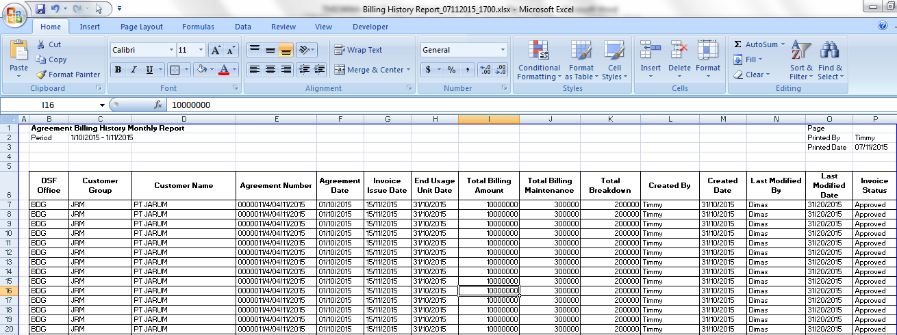

18

17

16

15

13

12

11

10

9

8

7

6

5

4

3

21

20

3

2

1

Print Preview

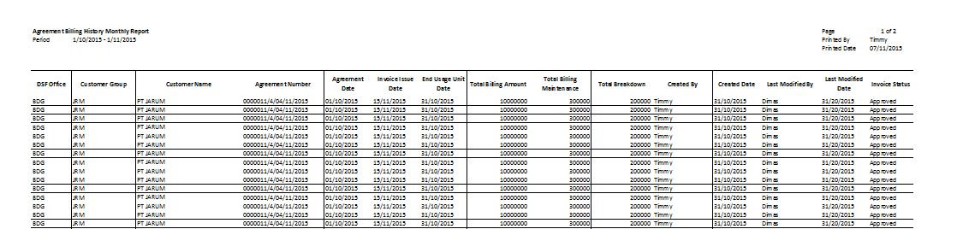

**RPT.AE.1.2 Reminder Memo History Report**

|  |  |  |  |  |
| --- | --- | --- | --- | --- |
| *No.* | *Content* | *Description* | *Source* | *Remarks* |
| 1 | File Name | Varchar | System Automatic generate | Reminder Memo History Report\_MMddyyyy\_hhmm where MMddyyyy and hhmm is the time when button Print Report is clicked |
| 2 | Report Title | Varchar | System defined | Reminder Memo History Report |
| 3 | Periode | Varchar | Start and End period at Search Criteria text field |  |
| 4 | Agreement Number | Varchar | OPLAgreement.AgreementNo | TB\_BIL\_ReminderMemoHistory. TB\_BIL\_PayScheduleID = TB\_BIL\_PaySchedule.TB\_BIL\_PayScheduleID and TB\_BIL\_PayScheduleID.IdOPLAgreement = OPLAgreement.IdOPLAgreement |
| 5 | Customer Name | Varchar | Customer.CustomerName | TB\_BIL\_PaySchedule.TB\_BIL\_PayScheduleID and TB\_BIL\_PayScheduleID.IdOPLAgreement = OPLAgreement.IdOPLAgreement  AND OPLAgreement.CustomerCode = Customer.CustomerCode |
| 6 | Reminder Date | Reminder Date | Tb\_BIL\_ReminderMemoHistory.ReminderDate |  |
| 7 | Reminder Type | Reminder Type | Tb\_BIL\_ReminderMemoHistory.ReminderType |  |
| 8 | Reminded By | Reminded By | Tb\_BIL\_ReminderMemoHistory.RemindedBy |  |
| 9 | Response | Response | Tb\_BIL\_ReminderMemoHistory.Response |  |
| 10 | Page | Varchar | Automatically count by number of page | Formula: N of X : where N is the current page and X is the total page of documents |
| 11 | Printed By | Varchar | User.UserName | Formula: Username is the one who login at system and click the Print Report button |
| 12 | Printed Date | Date | Use date in application server when button Print Report is clicked | Format display in report: MM/dd/yyyy |

**Note:**

Content number 2,3,19,20,21 will be page header format and will be printed in every page.

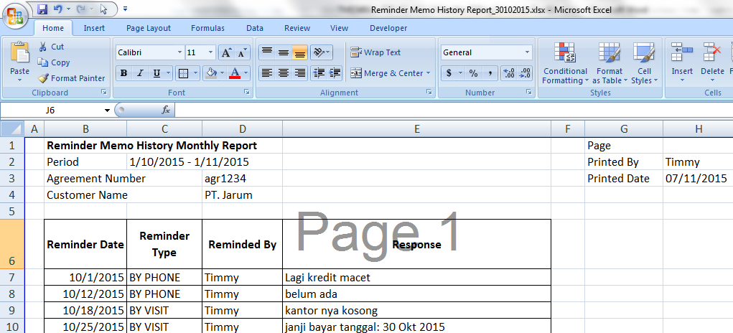

9

8

7

6

12

11

10

5

4

3

2

1

Print Preview

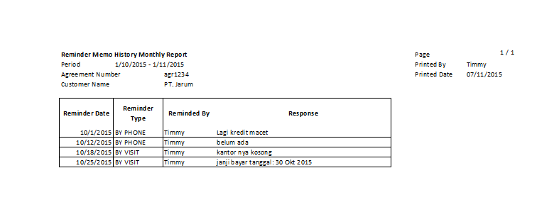

* 1. Entity Relationship Diagram

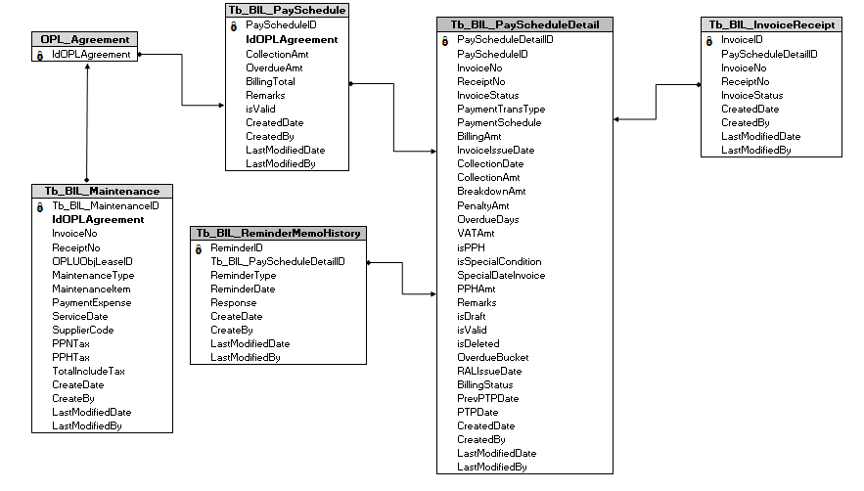

**APPENDIX**

Configuration Access for Monitor Billing Schedule:

|  |  |  |  |  |  |  |  |
| --- | --- | --- | --- | --- | --- | --- | --- |
| **User** | **Branch** | **Functions** | | | | | |
| **Display List** | **Create** | **Edit** | **View** | **Print Form** | **Print Report** |
| PIC Collection | One | V | V | V | V | V | V |
| Area |  |  |  |  |  |  |
| All |  |  |  |  |  |  |
| Head of Branch | One | V |  |  | V | V | V |
| Area |  |  |  |  |  |  |
| All |  |  |  |  |  |  |
| Head of Department | One |  |  |  |  |  |  |
| Area |  |  |  |  |  |  |
| All | V |  |  | V | V | V |
| Regional Manager | One |  |  |  |  |  |  |
| Area | V |  |  | V | V | V |
| All |  |  |  |  |  |  |
| Advisor | One |  |  |  |  |  |  |
| Area |  |  |  |  |  |  |
| All | V |  |  | V | V | V |
| Director | One |  |  |  |  |  |  |
| Area |  |  |  |  |  |  |
| All | V |  |  | V | V | V |
| President Director | One |  |  |  |  |  |  |
| Area |  |  |  |  |  |  |
| All | V |  |  | V | V | V |
| Shareholder's Meeting | One |  |  |  |  |  |  |
| Area |  |  |  |  |  |  |
| All | V |  |  | V | V | V |
|  |  |  |  |  |  |  |  |
| **Legend:** |  |  |  |  |  |  |  |
| V = Have the access |  |  |  |  |  |  |  |